 | News Hero!  Can you find a news article in a newspaper/magazine or online about a person or animal that has carried out a heroic act? Maybe they saved the day or helped somebody who was struggling. Which of our school values did the hero show? | Sumdog Spelling and Grammar  Use the Sumdog app or website on your device to complete the spelling and grammar activities set by your teacher.
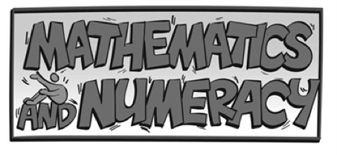 | Sumdog Maths  Use the Sumdog app or website on your device to complete the Maths activities set by your teacher. | Times Table Club!  Use the Times Tables Rock Stars (Times Tables Rock Stars – Times Tables Rock Stars (ttrockstars.com)) to practice your times tables! Practice makes perfect!
 | Polar Bear  This term we are looking at how animals are adapted to their environments. Can you draw a picture of a polar bear? Can you label the polar bear to show how it is adapted to survive in its habitat? | Communication is Cool!  We often use emails to communicate in school and have spent lots of time learning about the good features of an email. Can you use these features to write a letter to somebody?
 | My Hero  Can you research a famous hero? This might be a historical figure, a footballer, a key worker, a family member! Why are they a hero to you? | RE – A hero  Can you research a Saint or similar from any religion that was considered a hero? Make a poster displaying who they were and what they did. If you’re stuck have a look at Mother Tereasa !
 | Get Fit in 5!  Take 5 minutes out of your day to get your heart pumping faster! You can do this by going for a walk, jog, or run around your garden! You can do star jumps too! | Hockey  Can you create your own warm up which you could use before playing hockey? Think about raising your heart rate as well as stretching!
 | Art Attack!  Can you create your own piece of art depicting your own hero? This could be someone famous or someone closer to home. You can use any medium you have at home; pencils, paints etc. | Welsh Music  Using the internet or other resources can you find an example of Welsh Music to listen to and enjoy? This could be traditional or more modern!
Other information:
- Please continue to read every day and practise times tables
- Please feel free to complete any creative ideas of your own
- Any word processing or other ICT based learning needs to be uploaded to your HWB folder

