3/4 Homework Grid

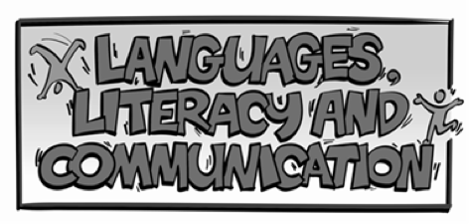 | Create a factfile about the famous Welsh artist, Kyffin Williams. Think about what important information you will need to include. | Write a diary for each day you are at home. Remember to use adjectives, verbs, adverbs, nouns and interesting connectives. | Read something new every day. This could be a book, newspaper, magazine or an online piece.
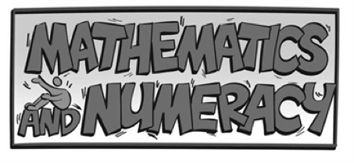 | Follow a recipe from the internet or cookbook. Weigh/measure out each ingredient and follow the step by step instructions. Remember to follow the timings too! | Using the example of the multiplication board game below, practise your times tables. Challenge yourself by choosing either easy, medium or hard levels. | Challenge a family member to do some timed exercises. Estimate how many completed exercises each family member can do. Can you round the number to the nearest 10, 100 or 1000?
 | Using j2data, create a graph to the results of your Maths family exercise activity. | Place ice cubes in various places around your house and garden (remember to use a cup!) Record how long it takes them to melt. Write a short paragraph to explain your findings. | Using 3D shapes, make a model of an object of your choice. You could use recycled materials to do this!
 | Create a journey to get from Welshpool to Zychlin in Poland. You will have to think about airports, ports, train/bus journeys as well as how much it will cost. | Research the floods of the 1960s in Newtown. What were the consequences of the floods? What changes were made to stop it happening again? | Read the Easter story with your family. Can you create an Easter card using your knowledge of the Easter story? We will judge them when we’re back!
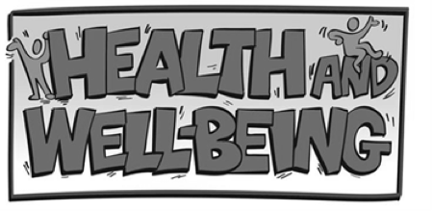 | Make a new rhyme or song to help people wash their hands for 40-60 seconds. | Create a hygiene poster to encourage your friends and family to wash their hands regularly. | Have a technology free day. What did you do instead? Write an account of what you have done.
 | Draw/paint/sketch a picture of the local area in the style of Welsh artist, Kyffin Williams. | Retell your favourite story to your family. Could you upload your performance to your HWB account? | Create a collage using recycled materials e.g. bottle tops, wrappers etc.
Other information:
- Please continue to read every day and practise times tables
- Please feel free to complete any creative ideas of your own.
- Any word processing or other ICT based learning needs to be uploaded to your HWB folder.
- Practise spellings using the lists below. This could be done in word groups of 5.

